# COMPUTER REPAIR AND MAINTENANCE

# Introduction

This unit specifies competencies required to perform computer repair and maintenance. It involves performing troubleshooting, disassembling of faulty components, repairing/replacing faulty components, testing of component functionality up gradation and testing of hardware and software.

# Disassembling the computer system

**Detach the power cable:** The disassembling of the computer system starts with externally connected device detachment. Make sure the computer system is turned off, if not then successfully shut down the system and then start detaching the external devices from the computer system. It includes removing the power cable from electricity switchboard, then remove the cable from SMPS (switch mode power supply) from the back of the CPU Cabinet. Do not start the disassembling without detaching the power cable from the computer system. Now remove the remaining external devices like keyboard, mouse, monitor, printer or scanner from the back of CPU cabinet.

**Remove the Cover:** The standard way of removing tower cases used to be to undo the screws on the back of the case, slide the cover back about an inch and lift it off. The screwdrivers as per the type of screw are required to do the task.

**Remove the adapter cards:** Make sure if the card has any cables or wires that might be attached and decide if it would be easier to remove them before or after you remove the card. Remove the screw if any, which holds the card in place. Grab the card by its edges, front and back, and gently rock it lengthwise to release it.

**Remove the drives:** Removing drives is easier. There can be possibly three types of drives present in your computer system, Hard disk drive, CD/DVD/Blue-ray drives. They usually have a power connector and a data cable attached from the device to a controller card or a connector on the motherboard. CD/DVD/Blue Ray drive may have an analog cable connected to the sound card for direct audio output.

**Remove the memory module:** Memory modules are mounted on the motherboard as the chips that can be damaged by manual force if applied improperly. Be careful and handle the chip only by the edges. SIMMs and DIMMs are removed in a different way:

* SIMM - gently push back the metal tabs while holding the SIMM chips in the socket. Tilt the SIMM chip away from the tabs until a 45% angle. It will now lift out of the socket. Put SIMM in a safe place.
* DIMM - There are plastic tabs on the end of the DIMM sockets. Press the tabs down and away from the socket. The DIMM will lift slightly. Now grab it by the edges and place it safely. Do not let the chips get dust at all

**Remove the power supply:** The power supply is attached into tower cabinet at the top back end of the tower. Make sure the power connector is detached from the switchboard. Start removing the power connector connected to motherboard including CPU fan power connector, cabinet fan, the front panel of cabinet power buttons and all the remaining drives if not detached yet. Now remove the screws of SMPS from the back of the cabinet and the SMPS can be detached from the tower cabinet.

**Remove the motherboard:** Before removing all the connectors from the motherboard, make sure u memorize the connectors for assembling the computer if required, as that may require connecting the connectors at its place. Remove the screws from the back of the motherboard and you will be able to detach it from the cabinet. Now remove the CPU fan from the motherboard. The heat sink will be visible now which can be removed by the pulling the tab upward. Finally, the processor is visible now, which can be removed by the plastic tab which can be pulled back one stretching it side way.

**Assembling the computer system:** The assembling of the computer system is exactly the opposite of disassembling operation.

# Computer Assembly Process

Step 1: Remove Side Panels on Case Step 2: Insert Motherboard

Step 3: Check Clearances

Step 4: Front Panel Connections Step 5: Install Power Supply Step 6: Power Motherboard Step 7: Installing Optical Drive

Step 8: Installing the Hard Drives Step 9: Connect Cables

Step 10: Install RAM

Step 11: Install Graphics Card and Expansion Cards Step 12: Cable Management

Step 13: Final Product

**Read:** Assembling new PC: https://[www.instructables.com/id/Computer-Assembly/](http://www.instructables.com/id/Computer-Assembly/)

**Establish Theory of Probable Cause** this is basically a strategic process of elimination by ruling out certain causes, which automatically create problems. You'll learn to determine which components to hone in on, what automatically assessments to make based upon the issue presented and how to conduct an assessment to accurately narrow down the root causes of the problem(s) being experienced.

**Read:** How to establish probable cause: https://[www.cybrary.it/video/establish-theory-](http://www.cybrary.it/video/establish-theory-) probable-cause/

**Watch:** Assemble and Disassemble a System Unit: https://youtu.be/tQ0YnRntlPA

**Test probable cause theory** to determine actual **cause**. Once you have established your **theory of probable cause**, you should take a moment to consider whether or not you can troubleshoot the issue on your own, or if escalating it to a higher authority is called for.

**Identify** and Define the **Problem**. The first step in the problem solving and decision making process is to identify and define the problem. A problem can be regarded as a difference between the actual situation and the desired situation.

**Hardware Tools:** For every job there is the right tool. Make sure that you are familiar with the correct use of each tool and that the correct tool is used for the current task. Skilled use of tools and software makes the job less difficult and ensures that tasks are performed properly and safely.

A toolkit should contain all the tools necessary to complete hardware repairs. As you gain experience, you learn which tools to have available for different types of jobs. Hardware tools are grouped into four categories:

* ESD tools
* Hand tools
* Cleaning tools
* Diagnostic tools

**ESD Tools:** There are two ESD tools: the antistatic wrist strap and the antistatic mat. The antistatic wrist strap protects computer equipment when grounded to a computer chassis. The antistatic mat protects computer equipment by preventing static electricity from accumulating on the hardware or on the technician.

**Hand Tools:** Most tools used in the computer assembly process are small hand tools. They are available individually or as part of a computer repair toolkit. Toolkits range widely in size, quality, and price. Some common hand tools and their uses are:

* **Flat-head screwdrive**r: Used to tighten or loosen slotted screws.
* **Phillips-head screwdriver**: Used to tighten or loosen cross-headed screws.
* **Torx screwdriver**: Used to tighten or loosen screws that have a star-like depression on the top, a feature that is mainly found on laptops.
* **Hex driver**: Used to tighten or loosen nuts in the same way that a screwdriver tightens or loosens screws (sometimes called a nut driver).
* **Needle-nose pliers**: Used to hold small parts.
* **Wire cutters**: Used to strip and cut wires.
* **Tweezers:** Used to manipulate small parts.
* **Part retriever**: Used to retrieve parts from locations that are too small for your hand to fit.
* **Flashlight**: Used to light up areas that you cannot see well.
* **Wire stripper**: A wire stripper is used to remove the insulation from wire so that it can be twisted to other wires or crimped to connectors to make a cable.
* **Crimper**: Used to attach connectors to wires.
* **Punch-down tool**: Used to terminate wire into termination blocks. Some cable connectors must be connected to cables using a punch down tool.

**Cleaning Tools:** Having the appropriate cleaning tools is essential when maintaining and repairing computers. Using the appropriate cleaning tools helps ensure that computer components are not damaged during cleaning. Cleaning tools include the following:

* **Soft cloth:** Used to clean different computer components without scratching or leaving debris
* **Compressed air:** Used to blow away dust and debris from different computer parts without touching the components
* **Cable ties:** Used to bundle cables neatly inside and outside of a computer
* **Parts organizer:** Used to hold screws, jumpers, fasteners, and other small parts and prevents them from getting mixed together

**Diagnostic Tools:** Diagnostic tools are used to test and diagnose equipment. Diagnostic tools include the following:

* A **digital multimeter** is a device that can take many types of measurements. It tests the integrity of circuits and the quality of electricity in computer components. A digital multimeter displays the information on an LCD or LED.

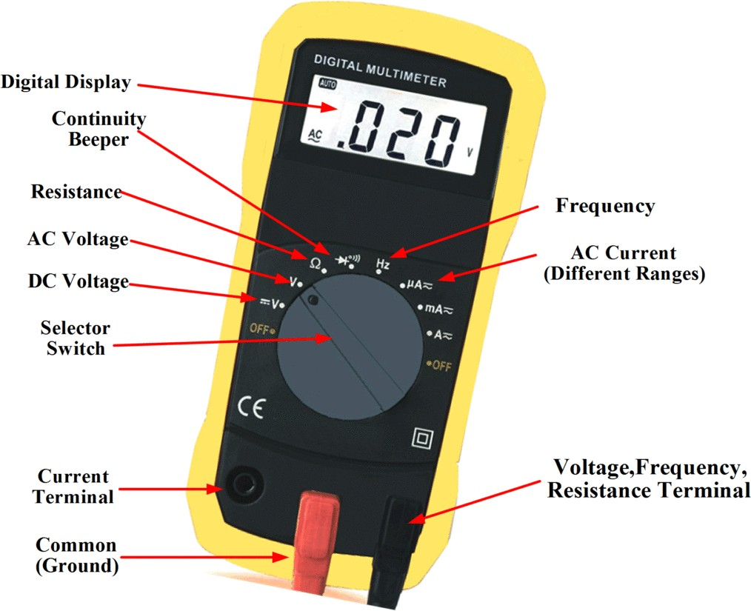

Source: [http://electricalacademia.com](http://electricalacademia.com/)

# Figure 72: Digital multimeter

* A **loopback adapter**, also called a loopback plug, tests the basic functionality of computer ports. The adapter is specific to the port that you want to test.
* The **toner probe**, as shown in Figure 2-4, is a two-part tool. The toner part is connected to a cable at one end using specific adapters, such as an RJ-45, coaxial, or metal clips. The toner generates a tone that travels the length of the cable. The probe part traces the cable. When the probe is in near proximity to the cable to which the toner is attached, the tone can be heard through a speaker in the probe.
* Although an **external hard drive** enclosure is not a diagnostic tool, it is often used when diagnosing and repairing computers. The customer hard drive is placed into the external enclosure for inspection, diagnosis, and repair using a known-working computer. Backups can also be recorded to a drive in an external enclosure to prevent data corruption during a computer repair.

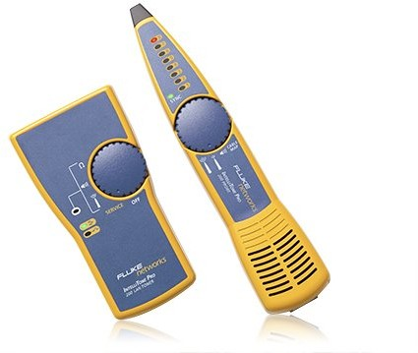

Source: https://[www.flukenetworks.com](http://www.flukenetworks.com/)

# Figure 73: Toner probe

**Software Tools:** Like hardware tools, there are a variety of software tools that can be used to help technicians pinpoint and troubleshoot problems. Many of these tools are free and several come with the Windows operating system.

**Disk Management Tools:** Software tools help diagnose computer and network problems and determine which computer device is not functioning correctly. A technician must be able to use a range of software tools to diagnose problems, maintain hardware, and protect the data stored on a computer.

You must be able to identify which software to use in different situations. Disk management tools help detect and correct disk errors, prepare a disk for data storage, and remove unwanted files.

The following are some disk management tools:

* **FDISK:** A command-line tool that creates and deletes partitions on a hard drive. The FDISK tool is not available in Windows XP, Vista, or 7. It has been replaced with the Disk Management tool.
* **Disk Management Tool:** Initializes disks, creates partitions, and formats partitions.
* **Format:** Prepares a hard drive to store information.
* **ScanDisk or CHKDSK:** Checks the integrity of files and folders on a hard drive by scanning the file system. These tools might also check the disk surface for physical errors.
* **Defrag:** Optimizes space on a hard drive to allow faster access to programs and data.
* **Disk Cleanup:** Clears space on a hard drive by searching for files that can be safely deleted.
* **System File Checker (SFC):** A command-line tool that scans the operating system critical files and replaces files that are corrupted.

**Protection Software Tools:** Each year, viruses, spyware, and other types of malicious attacks infect millions of computers. These attacks can damage operating systems, applications, and data. Computers that have been infected may even have problems with hardware performance or component failure.

To protect data and the integrity of the operating system and hardware, use software designed to guard against attacks and to remove malicious programs.

**Organizational Tools:** Keeping accurate records and journals during a busy workday can be challenging. Many organizational tools, such as work-order systems, can help the technician document their work.

**Reference Tools:** A technician must document all repairs and computer problems. The documentation can then be used as a reference for future problems or for other technicians who may not have encountered the problem before. The documents can be paper based, but electronic forms are preferred because they can be easily searched for specific problems.

It is important that a technician document all services and repairs. These documents need to be stored centrally and made available to all other technicians. The documentation can then be used as reference material for similar problems that are encountered in the future. Good customer service includes providing the customer with a detailed description of the problem and the solution.

**Personal Reference Tools:** Personal reference tools include troubleshooting guides, manufacturer manuals, quick reference guides, and repair journals. In addition to an invoice, a technician keeps a journal of upgrades and repairs. The documentation in the journal includes descriptions of the problem, possible solutions that have been attempted, and the steps taken to repair the problem. Note any configuration changes made to the equipment and any replacement parts used in the repair. This documentation is valuable when you encounter similar situations in the future.

* **Notes:** Make notes as you go through the troubleshooting and repair process. Refer to these notes to avoid repeating previous steps and to determine what steps to take next.
* **Journal:** Document the upgrades and repairs that you perform. Include descriptions of the problem, possible solutions that have been tried to correct the problem, and the steps taken to repair the problem. Note any configuration changes made to the equipment and any replacement parts used in the repair. Your journal, along with your notes, can be valuable when you encounter similar situations in the future.
* **History of repairs:** Make a detailed list of problems and repairs, including the date, replacement parts, and customer information. The history allows a technician to determine what work has been performed on a specific computer in the past.

**Internet Reference Tools:** The Internet is an excellent source of information about specific hardware problems and possible solutions:

* Internet search engines
* News groups
* Manufacturer FAQs
* Online computer manuals
* Online forums and chat
* Technical websites

**Miscellaneous Tools:** With experience, you will discover many additional items to add to the toolkit. Example roll of masking tape can be used to label parts that have been removed from a computer when a parts organizer is not available.

A working computer is also a valuable resource to take with you on computer repairs in the field. A working computer can be used to research information, download tools or drivers, and communicate with other technicians. Make sure that the parts are in good working order before you use them. Using known good components to replace possible bad ones in computers helps you quickly determine which component is not working properly.

# Demonstrate Proper Tool Use

**Antistatic Wrist Strap:** Safety in the workplace is everyone’s responsibility. You are much less likely to injure yourself or damage components when using the proper tool for the job.

Before cleaning or repairing equipment, make sure that your tools are in good condition. Clean, repair, or replace items that are not functioning adequately.

An example of ESD is the small shock that you receive when you walk across a carpeted room and touch a doorknob. Although the small shock is harmless to you, the same electrical charge passing from you to a computer can damage its components. Self-grounding or wearing an antistatic wrist strap can prevent ESD damage to computer components.

The purpose of self-grounding or wearing an antistatic wrist strap is to equalize the electrical charge between you and the equipment. Self-grounding is done by touching a bare metal part of a computer case. The antistatic wrist strap is a conductor that connects your body to the equipment that you are working on. When static electricity builds up in your body, the connection made by the wrist strap to the equipment, or ground, channels the electricity through the wire that connects the strap.

**Antistatic Mat:** You might not always have the option to work on a computer in a properly equipped workspace. If you can control the environment, try to set up your workspace away from carpeted areas. Carpets can cause the buildup of electrostatic charges. If you cannot avoid the carpeting, ground yourself to the unpainted portion of the case of the computer on which you are working before touching any components.

An antistatic mat is slightly conductive. It works by drawing static electricity away from a component and transferring it safely from equipment to a grounding point.

When you are working at a workbench, ground the workbench and the antistatic floor mat. By standing on the mat and wearing the wrist strap, your body has the same charge as the equipment and reduces the probability of ESD. Either connect the table-top mat and the floor mat to each other, or connect both to the electrical earth ground.

Reducing the potential for ESD reduces the likelihood of damage to delicate circuits or components.

**NOTE:** Always handle components by the edges.

**Hand Tools:** A technician needs to be able to properly use each tool in the toolkit.

* **Screws:** Match each screw with the proper screwdriver. Place the tip of the screwdriver on the head of the screw. Turn the screwdriver clockwise to tighten the screw and counterclockwise to loosen the screw. Screws can become stripped if you over-tighten them with a screwdriver. A stripped screw, as shown in may get stuck in the screw hole, or it may not tighten firmly. Discard stripped screws.
* **Flat-Head Screwdriver:** Use a flat-head screwdriver when you are working with a slotted screw. Do not use a flat-head screwdriver to remove a Phillips-head screw. Never use a screwdriver as a pry bar. If you cannot remove a component, check to see if there is a clip or latch that is securing the component in place.

**CAUTION:** If excessive force is needed to remove or add a component, something is probably wrong. Take a second look to make sure that you have not missed a screw or a locking clip that is holding the component in place. Refer to the device manual or diagram for additional information.

* **Phillips-Head Screwdriver:** Use a Phillips-head screwdriver with crosshead screws. Do not use this type of screwdriver to puncture anything. This will damage the head of the screwdriver.
* **Hex Driver:** Use a hex driver, to loosen and tighten bolts that have a hexagonal (six- sided) head. Hex bolts should not be over-tightened because the threads of the bolts can be stripped. Do not use a hex driver that is too large for the bolt that you are using.

**CAUTION:** Some tools are magnetized. When working around electronic devices, be sure that the tools you are using have not been magnetized. Magnetic fields can be harmful to data stored on magnetic media. Test your tool by touching the tool with a screw. If the screw is attracted to the tool, do not use the tool.

* **Component Retrieving Tools:** Needle-nose pliers and tweezers can be used to place and retrieve parts that may be hard to reach with your fingers. There are also tools called part retrievers that are specifically designed for this task. Do not scratch or hit any components when using these tools.

**CAUTION:** Pencils should not be used inside the computer to change the setting of switches or to pry off jumpers. The pencil lead can act as a conductor and may damage the computer components.

A computer technician needs proper tools to work safely and prevent damage to the computer equipment. A technician uses many tools to diagnose and repair computer problems:

* Straight-head screwdriver, large and small
* Phillips-head screwdriver, large and small
* Tweezers or part retriever
* Needle-nosed pliers
* Wire cutters
* Chip extractor
* Hex wrench set
* Torx screwdriver
* Nut driver, large and small
* Three-claw component holder
* Wire stripper
* Crimper
* Punch-down tool
* Digital multimeter
* Wrap plugs
* Small mirror
* Small dust brush
* Soft, lint-free cloth
* Cable ties
* Scissors
* Small flashlight
* Electrical tape
* Pencil or pen
* Compressed air

Various specialty tools, such as Torx bits, antistatic bags and gloves, and integrated circuit pullers, can be used to repair and maintain computers. Always avoid magnetized tools, such as screwdrivers with magnetic heads, or tools that use extension magnets to retrieve small metal objects that are out of reach. Using magnetic tools can cause loss of data on hard drives and floppy disks. Magnetic tools can also induce current, which can damage internal

computer components.

Additionally, there are specialized testing devices used to diagnose computer and cable problems:

* **Multimeter:** A device that measures AC/DC voltage, electric current, and other cable and electrical characteristics.
* **Power supply tester:** A device that checks whether the computer power supply is working properly. A simple power supply tester might just have indicator lights, while more advanced versions show the amount of voltage and amperage.
* **Cable tester:** A device that checks for wiring shorts or faults, such as wires connected to the wrong pin.
* **Loopback plug:** A device that connects to a computer, hub, switch, or router port to perform a diagnostic procedure called a loopback test. In a loopback test, a signal is transmitted through a circuit and then returned to the sending device to test the integrity of the data transmission.

# Cleaning Materials

Keeping computers clean inside and out is a vital part of a maintenance program. Dirt can cause problems with the physical operation of fans, buttons, and other mechanical components. On electrical components, an excessive buildup of dust acts like an insulator and traps the heat. This insulation impairs the ability of heat sinks and cooling fans to keep components cool, causing chips and circuits to overheat and fail.

**NOTE:** When using compressed air to clean inside the computer, blow the air around the components with a minimum distance of 4 in. (10 cm) from the nozzle. Clean the power supply and the fan from the back of the case.

**CAUTION:** Before cleaning any device, turn it off and unplug the device from the power source.

**Computer Cases and Monitors:** Clean computer cases and the outside of monitors with a mild cleaning solution on a damp, lint-free cloth. Mix one drop of dishwashing liquid with 4 oz (118 ml) of water to create the cleaning solution. If water drips inside the case, allow enough time for the liquid to dry before powering on the computer.

**LCD Screens:** Do not use ammoniated glass cleaners or any other solution on an LCD screen, unless the cleaner is specifically designed for the purpose. Harsh chemicals damage the coating on the screen. There is no glass protecting these screens, so be gentle when cleaning them and do not press firmly on the screen.

**CRT Screens:** To clean the screens of CRT monitors, dampen a soft, clean, lint-free cloth with distilled water and wipe the screen from top to bottom. Then use a soft, dry cloth to

wipe the screen and remove streaking.

**Components:** Clean dusty components with a can of compressed air. Compressed air does not cause electrostatic buildup on components. Make sure that you are in a well-ventilated area before blowing the dust out of the computer. A best practice is to wear a dust mask to make sure that you do not breathe in the dust particles.

Blow out the dust using short bursts from the can. Never tip the can or use the can upside down. Do not allow the fan blades to spin from the force of the compressed air. Hold the fan in place. Fan motors can be ruined from spinning when the motor is not turned on.

**Component Contacts:** Clean the contacts on components with isopropyl alcohol. Do not use rubbing alcohol. Rubbing alcohol contains impurities that can damage contacts. Make sure that the contacts do not collect lint from the cloth or cotton swab. Before reinstallation, use compressed air to blow lint off the contacts.

**Keyboards:** Clean a desktop keyboard with compressed air and then use a handheld vacuum cleaner with a brush attachment to remove the loose dust.

**CAUTION:** Never use a standard vacuum cleaner inside a computer case. The plastic parts of the vacuum cleaner can build up static electricity and discharge to the components. Use only vacuums that are approved for electronic components.

**Mice:** Use glass cleaner and a soft cloth to clean the outside of the mouse. Do not spray glass cleaner directly on the mouse. If cleaning a ball mouse, you can remove the ball and clean it with glass cleaner and a soft cloth. Wipe the rollers clean inside the mouse with the same cloth. Do not spray any liquids inside the mouse.

# Table 11: Computer cleaning materials

|  |  |
| --- | --- |
| Computer case and outside of monitor | Mild cleaning solution and lint-free cloth |
| LCD screen | LCD cleaning solution or distilled water and lint-free  cloth |
| CRT screen | Distilled water and lint-free cloth |
| Heat sink | Compressed air |
| RAM | Isopropyl alcohol and lint-free swab |
| Keyboard | Handheld vacuum cleaner with a brush attachment |
| Mouse | Glass cleaner and a soft cloth. |

**Read:** Laptop repair tools: <http://www.insidemylaptop.com/laptop-repair-tools/>

# Self-Assessment

1. List the hand tools for dissembling a computer?
2. List the diagnostic tools for dissembling a computer?
3. Dissemble a desktop
4. Clean a CPU
5. Clean a monitor
6. **Case situation:** You Are Support Technician. One of your customers has just installed a brand new printer for himself. This customer calls you after some time and says that every time he tries to print something, all he gets is some garbled text. However, the printer prints the test page fine. What do you think is the problem here?

**Factors to consider when replacing a component:**

With productivity plummeting, your decision will likely be made from an emotional standpoint, rather than solid data to support your decision.

Data Driven Decisions, Analyze the Costs, Consider the Age of Equipment, Consider the Cost of Repairs, Consider Downtime, Consider Safety, Consider Efficiency.

**Component testing** is defined as a software testing type, in which the testing is performed on each individual component separately without integrating with other components. It's also referred to as Module Testing when it is viewed from an architecture perspective.

# Self-Assessment

1. Define factors to consider when replacing components?
2. What is component testing?
3. **Case situation:** You are asked to maintain a computer lab at an institution. You see that their DVD/ CD drive is not working. What is your suggestion?
4. **Case situation:** You have received a call from a client saying that their laptop is not starting after it fell down from the bed. You client says that there is no outside damage. What will you tell you client?
5. If you have a PC with an ATX motherboard and case, can you replace it with a BTX motherboard?
   1. Yes
   2. Yes, if you set the jumpers
   3. Yes, if you add more screw holes
   4. Yes, if you remove some ports
   5. No
6. is defined as a software testing type, in which the testing is performed on each individual component separately without integrating with other components.
   1. Component testing
   2. RAM
   3. Chip extractor
   4. Motherboard

# Information Sheet

Best technicians tools to diagnose a computer are:

* Process Explorer., Process Explorer is a small utility available for free.
* Windows Sysinternals Suite, System Explorer, SIW (System Information for Windows)
* HWiNFO, Speccy,hddscan.

# Testing techniques

* Test system platform
* I/O signal conditioning
* Benchtop instrumentation
* Data acquisition hardware
* Test sequencing / automation
* Test Steps & application algorithms
* Operator and Engineering User Interface

When conducting functional tests, you typically need to follow a process that looks something like this:

* Use test data to identify inputs
* Determine what the expected outcome should be based on those inputs
* Run the test cases with the proper inputs
* Compare the expected results to the actual results

# Upgrade computer software/hardware

# Information Sheet

Here are the top reasons why you should always be upgrading your software to the latest version.

* Cyber crime is on the rise
* Personal data is at risk
* You might not be updating automatically
* Malware passes like the flu
* New features
* Support might end

# Benefits of upgrading hardware

* Enhanced Performance
* Increased Security
* Downtime is Reduced
* Better Communications
* Better Experience for your Employees

**Upgrading** your release of Identity Manager provides several advantages, including:

* Access to advanced features and functionality
* A more secure environment for your servers
* Continued eligibility for full support and services

# Software Upgrade Process:

1. **Identify and engage your stakeholders**

Remember to include both internal and external stakeholders. End users, trainers, content developers, administrators, support and hosting teams, QA and testing teams, system owners, external suppliers, and service partners. Work out how each group interacts with the system, how an upgrade will affect them, and what level of ongoing engagement they might require.

# Undertake change control planning

Besides the technical work involved in upgrading your system, effective change control will probably be the biggest challenge surrounding a software upgrade. Keeping the balance between adequate communication and consultation, and overwhelming stakeholders with detail can be difficult.

# Perform a site review

Performing a site review involves taking a stock of any and all customizations within the site. Identify all bespoke developments and dig out the specifications and other relevant documentation relating to this work.

# Establish upgrade requirements

Based on your site review, do you need to re-develop customizations and integrations or upgrade bespoke plugins? Do you need to make allowance for historical data from those customizations? Can you upgrade to the latest version of the software from your current version or do you need to upgrade to a more recent version first? Check the technical specifications of the new software—do you need to upgrade, install, or purchase anything as part of the upgrade? Do you also need (or want) to upgrade your theme/design or will it work on the upgraded version?

# Make an upgrade plan

Who will perform the upgrade? What needs to be upgraded? What needs to be redeveloped? Does anything need to be newly developed? How will the upgrade be performed? Is there any guidance on the upgrade from the software supplier? What time, people, resources, and budget do you need to apply to the upgrade process?

# Make a roll-out plan

When will the upgrade be performed? Will there be an outage? How long will it be? What sort of message needs to go out to stakeholders? What will be the implementation process? What is your rollback plan?

# Backup everything

Store that backup somewhere very safe and secure. Backup again, and store that file somewhere else safe and secure.

# Run a trial upgrade

The best way to know if any issues will crop up during the upgrade is to try upgrading a copy of the live site. It will identify any code and/or database conflicts and where further work will be required.

# Upgrade a staging site

Once the technical aspect of the upgrade has been completed and any issues resolved, it’s time to upgrade a copy of the live site to a staging or testing environment.

# Perform testing

This includes functional, non-functional and technical testing, quality assurance, data integrity, security, performance, and theme/design testing including browser, and device testing.

# Undertake configuration

With your freshly upgraded staging site now deployed, tested and issues resolved, site administrators will need some time to ensure any new features and functionality introduced by the updates are configured correctly.

# Prepare documentation

Preparing help files or user manuals, as well as technical documentation detailing any custom developments or deployment requirements is vital to the success of your current upgrade as well as any future upgrades.

# Provide training

Training the right people at the right time not only requires adequate training resources but adequate planning. Trainers and the trainees need to be available at the same time, in a suitable space.

# Prepare your infrastructure

If your upgrade introduces a number of significant changes or you are timing the software upgrade with a re-release of the system, you will need to ensure your hosting setup will be able to cope with an increase in access and usage—if only for a short period of time.

# Go Live

You have a few options around your go-live including a complete switchover or running the old system and updated system in parallel for a period of time

# Offer support

There will probably be an initial demand on support resources after an upgrade has been released as users become acquainted with the new system. Changes to ongoing support might be required as a result of new system features and functionality or changes to processes and policies.

# Perform an upgrade review

It is important to review the upgrade project in retrospect to identify what worked well and where improvements can be made for the next time an upgrade is required.

# Self-Assessment

1. Describe process of software and hardware upgrading?
2. Why might a company need to upgrade their hardware? Provide examples to reason.
3. You have a few options around your including a complete switchover or

running the old system and updated system in parallel for a period of time.

* 1. Go Live
  2. Provide Training
  3. Backup Everything

1. Upgrading your release of Identity Manager provides several advantages, including:
   1. Access to advanced features and functionality
   2. A more secure environment for your servers
   3. Continued eligibility for full support and services
   4. All are True
   5. Only A and B are correct